LAB# 07 (OPEN-ENDED LAB):
Questions:
C. Create three threads using Runnable with different names and priorities. Each thread should print its name, priority, and count 5 times, pausing with sleep(). Synchronize the printing and change thread priorities dynamically during execution.
CODE:
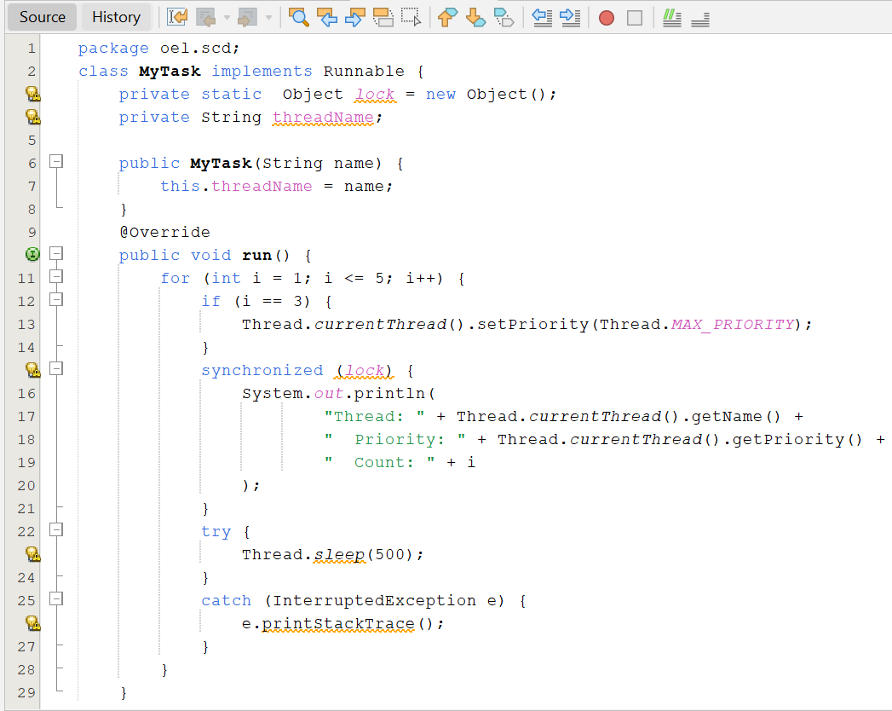

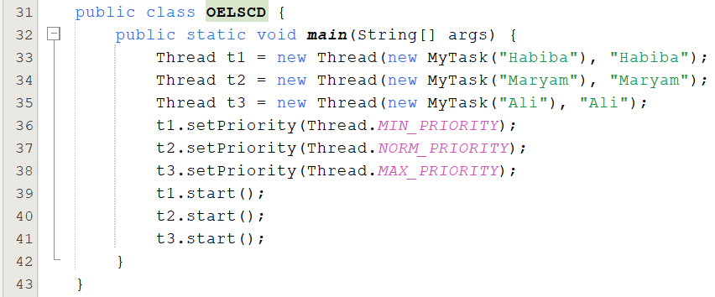

OUTPUT:
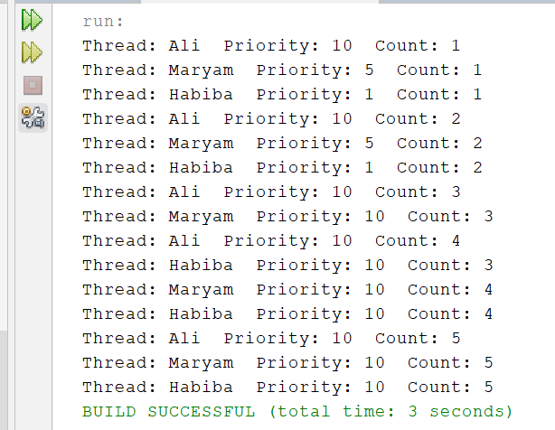

D. Implement a parking lot system with 20 spots where multiple users can reserve spots concurrently. If requested spots exceed availability, show an error; otherwise, update and display booked and remaining spots. [Use threads and synchronized blocks to ensure safe concurrent reservations].
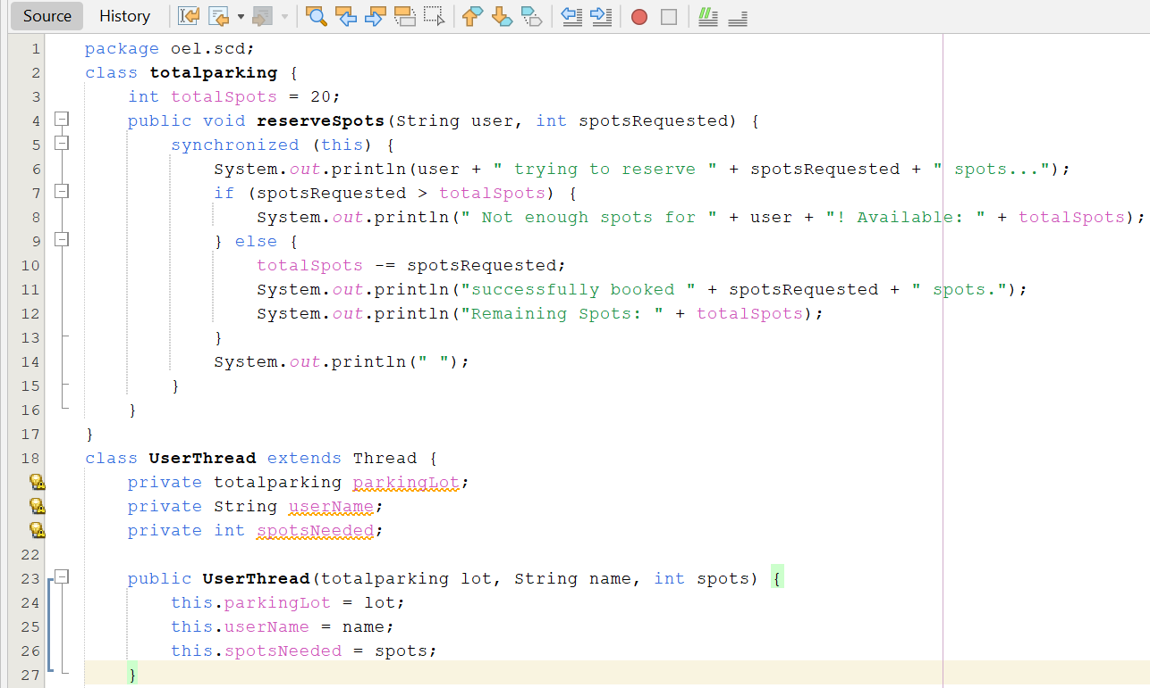
CODE:

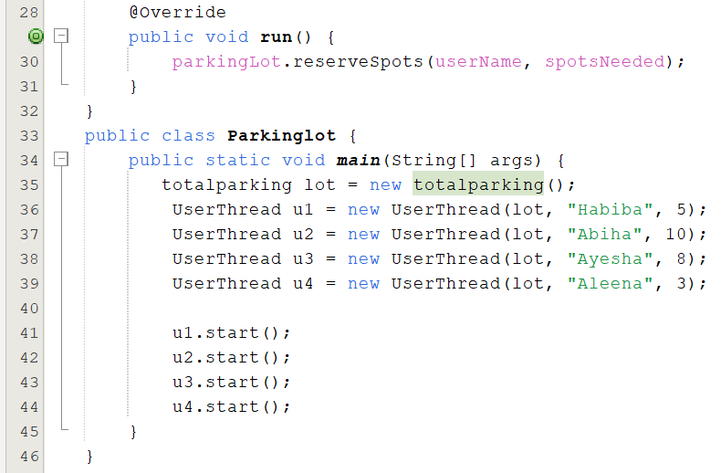

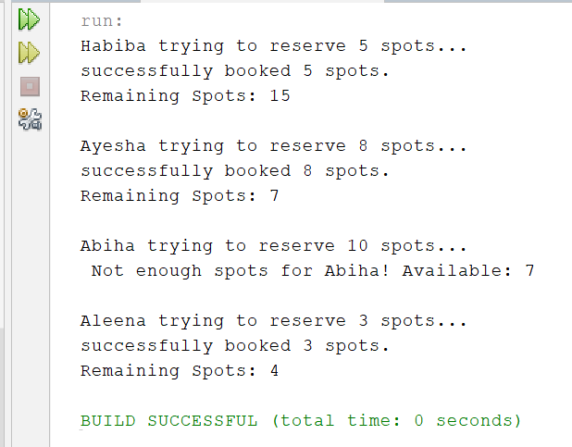
OUTPUT:

